Assistant training - Best ways to prep for a job!

When preparing the next job for the Operators, knowing what backing they’ll use is helpful so you can get it for them.

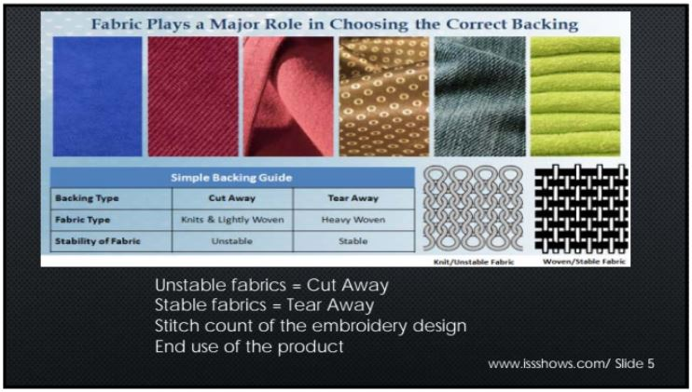

Tear away (E-ZEE Tear Crisp 1.8)

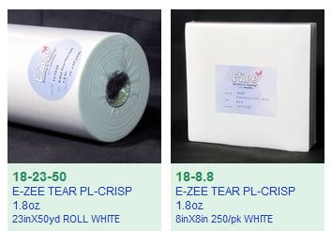

**This should be used exclusively on Non-stretch fabrics.** If a garment is stretchy - tear away can be used behind a cutaway backing but not alone. Using tear away on a stretchy fabric by itself can rip the material in the corners of the embroidery. The embroidery will also look bad after being washed.

If your embroidery has any puckering or distortion when using tear away on a non-stretch fabric, it is not enough structure.

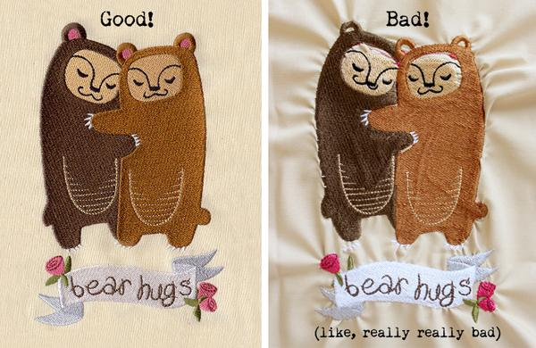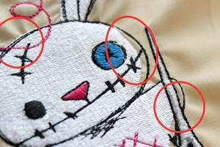

If you notice these QC issues, Alert the operator that 1 sheet of tear away might not be enough. Try two sheets offset from each other.

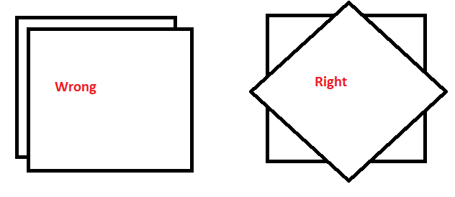

Do not pull both off at the same time, pull one off and then the other!

Hat tear away (EZEE Cap 2.5)

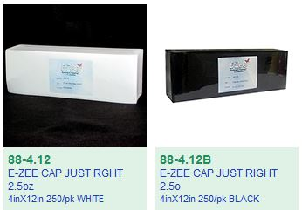

Use black backing on dark hats and white backing on light colored hats.

Cutaway backings should be used on any fabric that has a stretch. If the garment’s fabric is thin, you will want to pair it with an equally thin backing. If the embroidery is particularly dense, a thicker backing might be necessary. If the cutaway backing does not provide enough structure, a tearaway backing can be added behind it for better results.

**It is not ideal to use more then 1 cut away because then it might show through the shirt.**

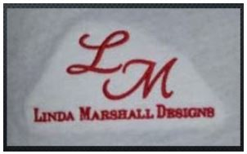

Thin Mesh (EZEE Weblon Noshow)

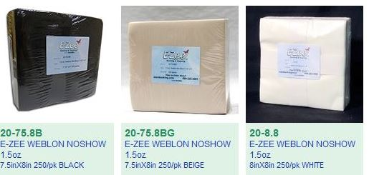

This backing is best for workout performance knits and thin dress shirts. Black for dark colors, white for light colors and beige for see through garments. The beige actually blends in with skin tone.

Woven Cutaway (EZEE Cut Performance)

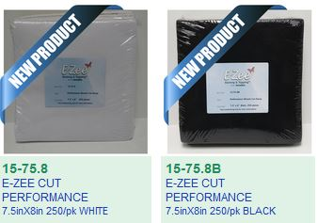

This backing works very well for dress shirts and designs that have a higher embroidery density. Use black for dark colors and white for lighter colored garments.

EZEE CUT 2.5 Just Right

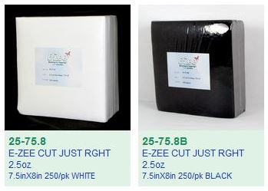

This should be your go to for cutaways. Use black on darker colors and white on lighter colors.

**Again a reminder**

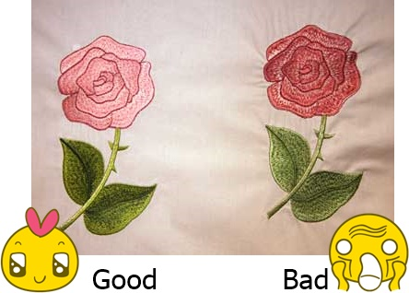

If you see embroidery coming off the machine with puckering, show the operator immediately because they need to change up their strategy.

If the next thicker backing causes an “embroidery badge”



Then try the thinner cutaway backing but with two tearaways set at an angle from each other.



Remember, when removing 2 sheets of tearaway, do one at a time!

Water Soluble Topping (E-ZEE AQUA SUPREME)

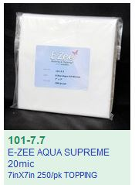

This should always be used if the fabric is shaggy (towels or fleece) or when the stitches sink into the fabric. Use it on tiny lettering.

3mm Foam (Do not use craft foam from craft store)

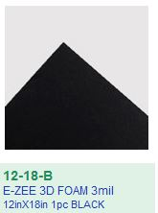

Try to match the color of the foam to the color of the 3D part of the embroidery.